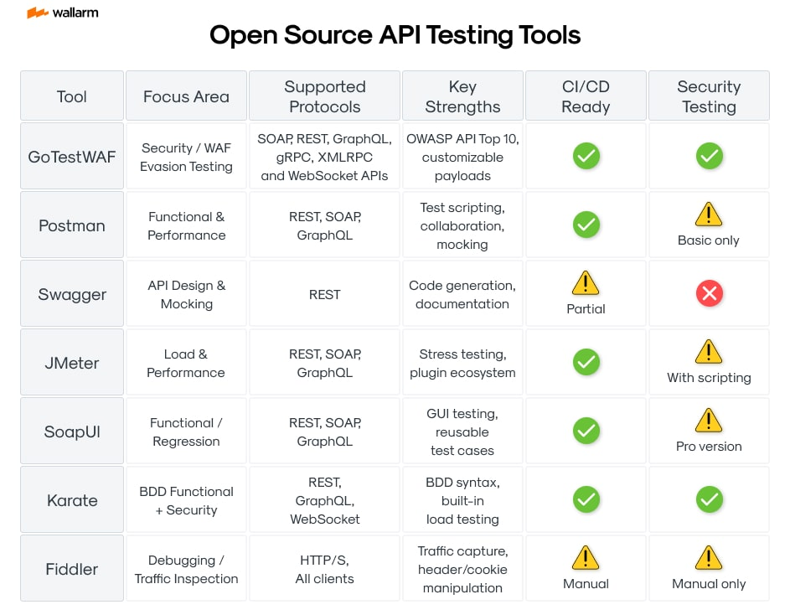

https://www.wallarm.com/what/api-security-tutorial

Table: Protocol Overview
Protocol | Format | Organized in terms of | Use cases
SOAP | XML only | enveloped message structure | - Large enterprise environments  - CRM solution  - Payment gateway  - Identity management  - Healthcare, financial and telecommunication services  - Legacy system support
XML-RPC | XML, HTTP | human-readable-and-writable, script-parsable standard for HTTP-based requests and responses | - Linking computers  - Connecting different types of environments  - Creating open software interfaces
MQTT | binary based protocol | open messaging | - IoT and IIoT infrastructures  - Machine-to-Machine (M2M) communication  - Automotive, Industry 4.0, Transportation and Entertainment
XMPP | XML | instant messaging (IM), presence information, and contact list maintenance | - Instant messaging applications  - Internet of Things (IoT)  - Online Gaming  - Social  - WebRTC, Data Syndication
REST | JSON, XML, HTML, plain text | with six architectural constraints | - Public API  - Simple resource-driven apps
JSON-RPC | JSON | sending multiple calls to the server | - Fast and reliable information exchange  - Used on Ethereum
Webhooks | JSON, HTTP | "user-defined HTTP callbacks" | - Connection between applications  - Email marketing  - CRM solutions
GraphQL | JSON | schema and type system | - Mobile, smartwatches and IoT API  - Complex system  - Microservices  - Creating a data schema
CoAP | simple binary base header format | multicast support, for simple conversion to HTTP | - IoT infrastructure  - Machine-to-machine (M2M) applications such as smart energy and building automation
‍gRPC | JSON, XML, Protobuf, Thrift, Flatbuffers | local procedure call | - Command and actio-oriented APIs  - D2D and D2C for embedded systems  - High perfomance communication in massive micro-services system and cloud enviroment  - Unified IPC and remote communication

https://en.wikipedia.org/wiki/OAuth
OAuth framework specifies several grant types for different use cases. Some of the most common OAuth grant types are:[22]
- Authorization Code
- PKCE
- Client Credentials
- Device Code
- Refresh Token
- Resource Owner Password Credentials (ROPC)

Day 1: API Fundamentals Simplified
↳ lnkd.in/e8eMet_k
↳ lnkd.in/er9JiGxw
Day 2: API Methods & Terminologies
↳ lnkd.in/ey9v7-hU
↳ lnkd.in/eRsPMzpd
Day 3: API Authentication & Status Codes
↳ lnkd.in/eNPfpAdE
↳ lnkd.in/egXizUrS
Day 4: REST API vs GraphQL + Integration Basics
↳ lnkd.in/eZHREdgC
↳ lnkd.in/eDASPP5m
Day 5: Deep Dive into API Integration
↳ lnkd.in/eZwFVrH7
↳ lnkd.in/e4WGDffA
Day 6: API Testing Fundamentals
↳ lnkd.in/emgmWJqH
↳ lnkd.in/eCPnGTGi
Day 7: Working with APIs in Python
↳ lnkd.in/eM23ah2y
Day 8: API Scaling Essentials
↳ lnkd.in/e3mZSvmn
Day 9: Developing Robust APIs
↳ lnkd.in/eBXzbFyg
Day 10: Hands-on with Postman
↳ lnkd.in/ezue3d4B
Day 11: API Security Deep Dive
↳ lnkd.in/e79ZYfPa

